《日内瓦教理问答》中英文（1—20问答）
原创 何奇伟 被释放的乌戈利诺 2019-11-26

《日内瓦教理问答》
Geneva Catechism
中英文对照
（1—20问答）

作者：约翰·加尔文牧师
译者：何奇伟（Francis. H）

16世纪欧洲宗教改革（Reformation）时期，约翰·加尔文（John Calvin）牧师亲自为基督的教会撰写了一部总共有370问答的《教理问答》（Catechism），史称《日内瓦教理问答》（Geneva Catechism），在1545年发布给教会，用于教导孩童。

在《日内瓦教理问答》最开头处的〈献词〉与〈致读者〉里，加尔文牧师提到，在新约教会古老的时期，也就是在使徒时代和教父时期，教会的诸圣先贤们便撰写教理问答，使用教理问答来向信众们教导基督教信仰的基要真理。但随着“罗马天主教”渐渐成形，有形教会在中世纪晚期渐渐丢失并忽略了教理问答的重要性，教理问答的使用甚至被罗马天主教教皇命令废止。然而，宗教改革运动促使改革家们再次恢复了这一优良的传统（“the use of the Catechism ... was abolished some centuries ago under the Papacy, ... now resume its lost rights.”——加尔文）。

1545年《日内瓦教理问答》封面

笔者喜爱《日内瓦教理问答》，并常用它进行灵修、启发思考。2019年11月24日起，笔者从第1问答开始翻译，因为急于推广分享给华人界，翻译迅速，以后会有所润色。转载请一定注明出处、译者姓名。

Master - What is the chief end of human life?
Scholar - To know God by whom men were created.
1问：人生的首要目的是什么？
答：人生的首要目的是认识上帝，因为我们被祂而造。

Q. 2. What reason have you for saying so?
A. Because He created us and placed us in this world to be glorified in us. And it is indeed right that our life, of which Himself is the beginning, should be devoted to His glory.
2问：你如此说，理由为何？
答：因上帝创造了我们，并安置我们在此世，为在我们里面得荣耀。我们的生命以祂为开端，故将之敬献于祂的荣耀，这是正确且应当的。

Q. 3. What is the highest good of man?
A. The very same thing.
3问：人生的至善是什么？
答：人生的至善也是认识上帝。

Q. 4. Why do you hold that to be the highest good?
A. Because without it our condition is worse than that of the brutes.
4问：为什么人生的至善也是认识上帝？
答：因为若不认识上帝，我们的处境就比禽兽更加恶劣。

Q. 5. Hence, then, we clearly see that nothing worse can happen to a man than not to live to God.
A. It is so.
5问：从而，我们看明白了，没有什么比不为上帝而活更加恶劣的了。
答：正是如此。

Q. 6. What is the true and right knowledge of God?
A. When He is so known that due honour is paid to Him.
6问：对上帝的真实且正确的知识是什么？
答：我们如此认知祂，以至于正确尊荣祂。

Q. 7. What is the method of honouring Him duly?
A. To place our whole confidence in Him; to study to serve Him during our whole life by obeying His will; to call upon Him in all our necessities, seeking salvation and every good thing that can be desired in Him; lastly, to acknowledge Him both with heart and lips, as the sole Author of all blessings.
7问：怎样才是正确尊荣上帝呢？
答：将我们全部的信心放在祂里面；学习以顺服祂的旨意而一生一世事奉祂；在我们一切所需上求告祂；在祂里面寻求并渴慕救恩和一切美善；最后，不仅用心，也用口舌，承认祂是一切福分的唯一源泉。

Q. 8. To consider these points in their order, and explain them more fully-What is the first head in this division of yours?
A. To place our whole confidence in God.
8问：按次序来考虑，更完整地解释——这些里面，第一项是什么？
答：将我们全部的信心放在祂里面。

Q. 9. How shall we do so?
A. When we know Him to be Almighty and perfectly good.
9问：我们怎样才能将全部的信心放在上帝里面呢？
答：我们应当认识上帝，知道祂是至高至大、至全至善者。

Q. 10. Is this enough?
A. Far from it.
10问：这就够了吗？
答：远远不够。

Q. 11. Wherefore?
A. Because we are unworthy that He should exert His power in helping us, and show how good He is by saving us.
问：为何？
答：因为我们不配，祂于是必须施行祂的能力来帮助我们，并借着拯救我们而向我们显出祂是多么美善。

Q. 12. What more then is needful?
A. That each of us should set it down in his mind that God loves him, and is willing to be a Father, and the Author of salvation to him.
12问：还需要什么？
答：我们每个人都应当专注明白，上帝爱我们并愿意作我们的父，又作我们救恩的源泉。

Q. 13. But whence will this appear?
A. From His word, in which He explains His mercy to us in Christ, and testifies of His love towards us.
13问：但你从何处知道的呢？
答：从祂的道，祂在道中阐明祂在基督里对我们所施的怜悯，并见证祂对我们的爱。

Q. 14. Then the foundation and beginning of confidence in God is to know Him in Christ?
A. Entirely so.
14问：所以，信仰上帝的根基与开端，便是在基督里认识祂？
答：完全如此。

Q. 15. I should now wish you to tell me in a few words, what the sum of this knowledge is?
A. It is contained in the Confession of Faith, or rather Formula of Confession, which all Christians have in common. It is commonly called the Apostles' Creed, because from the beginning of the Church it was ever received among all the pious, and because it either fell from the lips of the Apostles, or was faithfully gathered out of their writings.
15问：现在请用几句话告诉我，关于上帝的知识总结在何处？
答：对上帝的知识包含在信仰告白中，或称认信准则，所有基督徒共同持守。它通常被称为《使徒信经》，因为它自教会之起初便由一切敬虔之人所领受，又因使徒们亲口教导，抑或教会从使徒们的作品里忠实地归纳总结。

Q. 16. Repeat it.
A. I believe in God the Father Almighty, maker of heaven and earth; and in Jesus Christ, his only Son, our Lord, who was conceived by the Holy Ghost, born of the Virgin Mary, suffered under Pontius Pilate, was crucified, dead, and buried: he descended into hell; the third day he arose again from the dead; he ascended into heaven, and sitteth on the right hand of God the Father Almighty, from thence he shall come to judge the quick and the dead. I believe in the Holy Ghost; the holy Catholick Church; the communion of saints; the forgiveness of sins; the resurrection of the body; and the life everlasting. Amen.
16问：背诵《使徒信经》。
答：我信全能父上帝，天地的创造者。我信耶稣基督，上帝的独生子，我们的主；祂藉圣灵感孕，从童贞女马利亚所生；在本丢彼拉多手下受难，被钉十字架，受死，被埋葬；降在阴间；第三天从死人中复活；升天，坐在全能父上帝的右边；将来必从那里降临，审判活人、死人；我信圣灵；我信圣洁大公之教会；我信圣徒相通；我信罪得赦免；我信身体复活；我信永生。阿们。

Q. 17. To understand each point more thoroughly, into how many parts shall we divide this confession?
A. Into four leading ones.
17问：为更彻底理解每个要点，我们把这信仰告白划分为几部分？
答：四部分。

Q. 18. Mention them to me.
A. The first relates to God the Father; the second to his Son Jesus Christ, which also embraces the whole sum of man's redemption; the third to the Holy Spirit; the fourth to the Church, and the Divine blessings conferred upon her.
18问：哪四部分？
答：第一部分讲论父上帝；第二部分讲论祂儿子耶稣基督，也涉及人的救赎；第三部分讲论圣灵；第四部分讲论教会及上帝赐予她的福分。

Q. 19. Since there is no God but one, why do you here mention three, the Father, Son, and Holy Spirit?
A. Because in the one essence of God, it behoves us to look on God the Father as the beginning and origin, and the first cause of all things; next the Son, who is his eternal Wisdom; and, lastly, the Holy Spirit, as his energy diffused indeed over all things, but still perpetually resident in himself.
19问：既然只有一个上帝，你为什么说有三位，就是父、子、圣灵呢？
答：因为在上帝的独一本质中，我们理应将父上帝看作是万有的开端、起源、第一因；将子看作是父的永恒智慧；将圣灵看作是父那遍及万有的能力，也是永久居住于父自己之内。

Q. 20. You mean then that there is no absurdity in holding that these three persons are in one Godhead, and God is not therefore divided?
A. Just so.
20问：你的意思是，这三个位格为同一上帝，而上帝又没有因此被分割开，持定这样的信仰一点也不荒谬吗？
答：一点也不荒谬。

《日内瓦教理问答》1—20问答译完。译者：何奇伟（Francis. H）

记念作者——教会圣人加尔文牧师

“从前引导你们、传讲上帝之道给你们的人，你们要记念他们，效法他们的信仰，留心看他们为人的结局。耶稣基督昨日今日一直到永远，是一样的。”（《希伯来书》13:7—8）

笔者祈愿，上帝使我们谦卑沉静、回归古道，逃离错谬和谎言，在那圣洁而馨香的教理问答中寻找真正永恒的安慰！

推荐笔者翻译的一部为幼年儿童所写的《教理问答》：《小儿童教理问答》（中英文）
最后附上笔者建议的信经信条学习顺序：

笔者其他相关文章推荐：① 教理问答的历史传统② 什么是信经、信条、教理问答？③ 如何用教理问答进行灵修？④ 《日内瓦教理问答》推介及摘译⑤ 记念圣徒：约翰·加尔文⑥ 喝纯净的灵奶，还是吃当代的垃圾？
⑦ 你没听过的清教徒起源故事⑧ 圣徒年历、加尔文、古旧福音派
⑨ 古旧的福音派

本公众号神学立场：一个“极端改革宗”的信仰告白
“认信”的概念及我的认信 （何奇伟）

- 完 -

长按下图打赏，支持作者事工

【被释放的乌戈利诺】
分享古旧文艺与人文思想感悟

“被囚于高塔，饥饿痛苦中撕咬着自己的肉体，直等到死亡的降临。乌戈利诺伯爵的境况是我们每个人的现实，不过，众人早已习惯了被囚禁，唯有那极少数的梦想者还在仔细聆听，望着牢笼外的月亮，期待着自由。”

生命短暂，技艺长存

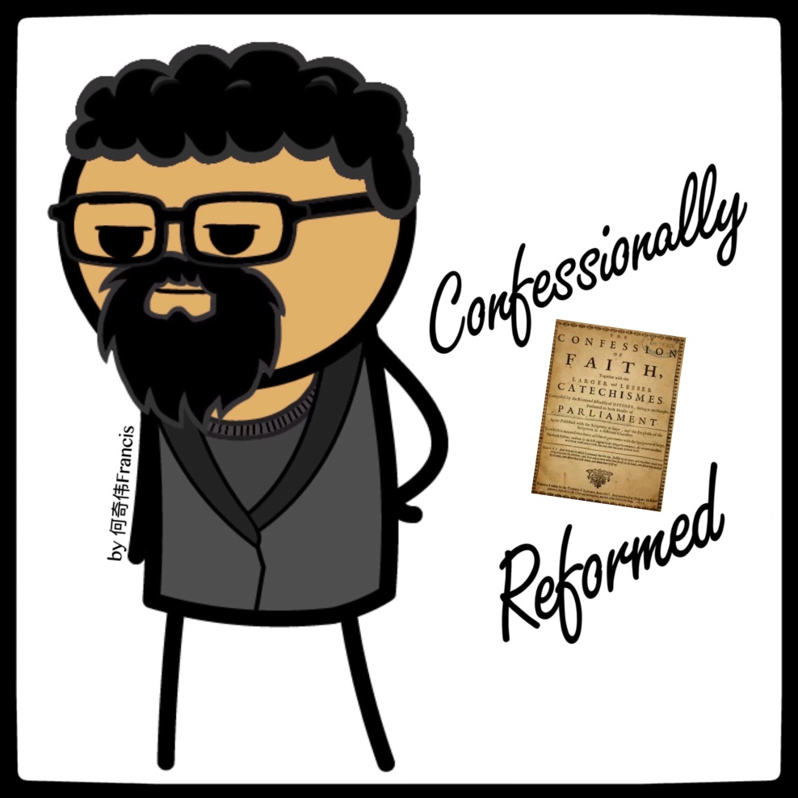
何奇伟
感谢支持文字事工
喜欢作者
阅读 78
文章已于2019/11/26修改
分享收藏
赞在看3
写下你的留言
精选留言
- 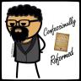
奇伟Francis(Φρανσις)
(朋友)
公开挑战！ 众所周知，教理问答（Catechism）是古公教会传统，但在中世纪晚期被罗马教皇废除。16世纪宗教改革运动时，誓反教（Protestant）恢复了这一传统，然后罗马教“山寨”誓反教的教理问答，也编写出自己的教理问答。 誓反教的教理问答，最早的是1529年《路德小教理问答》，然后著名的有约翰·加尔文1545年《日内瓦教理问答》，接下来有1563年《海德堡教理问答》，最后还有1640年代的《威斯敏斯特小教理问答》和《威斯敏斯特大教理问答》。 我挑战罗马教徒列出罗马教/教皇派最早的教理问答～ 2020.12.1

